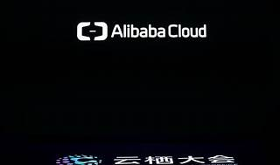

Explore

**Alibaba Cloud**, also known as **Aliyun**, is a Chinese cloud computing company and a subsidiary of Alibaba Group. It provides cloud computing services to online businesses and Alibaba’s own e-commerce ecosystem. [As the fourth-largest public cloud provider globally, it offers a wide range of services, including elastic compute, data storage, relational databases, big-data processing, anti-DDoS protection, and content delivery networks (CDN)](https://en.wikipedia.org/wiki/Alibaba_Cloud) [1](https://en.wikipedia.org/wiki/Alibaba_Cloud). Here are some free resources to learn more about Alibaba Cloud:

1. [**Alibaba Cloud Knowledge Base**](https://www.alibabacloud.com/knowledge/what-is-cloud-computing): Explore cloud computing fundamentals and concepts.
2. [**Alibaba Cloud Academy E-Learning Courses**](https://www.alibabacloud.com/academy/elearning): Access online courses covering various technologies and solutions, such as cloud computing, big data, security, and AI.
3. [**Alibaba Cloud Academy Skills Center**](https://www.alibabacloud.com/academy/skills-and-training-center): Learn basic cloud skills and best practices through virtual training.
4. [**Alibaba Cloud Training**](https://edu.alibabacloud.com/student/training): Attend classroom training sessions on cloud technologies.
5. [**Alibaba Cloud Academy**](https://edu.alibabacloud.com/): Explore instructor-led training and collaborative learning experiences at no cost.

Feel free to dive into these resources and enhance your understanding of Alibaba Cloud! 🌐🚀